**Student Timetable Viewer using HTML, CSS, and JavaScript**

**🎯 Aim**

The aim of this project is to design and implement a **web-based student timetable viewer** that allows students to view their **weekly class schedules** in a tabular format. The viewer includes a **filtering option** to display the timetable based on either the selected day or subject. The project uses only **HTML, CSS, and JavaScript**, and focuses on clean design, functional interactivity, and visual clarity.

This project also aims to help learners understand how to create **interactive web applications** without using complex frameworks. It emphasizes the importance of **data representation using HTML tables**, enhancing UI through **CSS styling**, and adding interactivity with **JavaScript filters**. The end goal is a functional timetable system that is easy to navigate and visually structured for academic use.

**🎯 Objective**

* To display a **weekly timetable** in a structured table format.
* To provide a filter option by **day** or **subject** using a dropdown menu.
* To enhance the readability and appeal of the timetable using **colors** and **styling**.
* To use **HTML** for content layout, **CSS** for styling, and **JavaScript** for filtering functionality.
* To create a responsive and user-friendly interface for students.

**🛠️ Project Steps**

1. Create the base layout of the webpage using HTML.
2. Design the timetable using a **table element** with days as rows and time slots as columns.
3. Implement **dropdown menus** to filter the timetable by day or subject.
4. Use **CSS** to apply colors, borders, hover effects, and responsive formatting.
5. Write **JavaScript** to dynamically show/hide rows based on selected filters.
6. Test the filtering functionality to ensure accurate display.
7. Finalize design for usability and clarity.

**💻 Code**

**✅ HTML**

<!DOCTYPE html>

<html lang="en">

<head>

<meta charset="UTF-8" />

<meta name="viewport" content="width=device-width, initial-scale=1.0"/>

<title>Student Timetable Viewer</title>

<link rel="stylesheet" href="110.css" />

</head>

<body>

<header>

<h1>Student Timetable Viewer</h1>

<p>View your weekly class schedule below</p>

</header>

<div class="filters">

<label for="day">Filter by Day:</label>

<select id="day" onchange="filterTable()">

<option value="all">All</option>

<option value="Monday">Monday</option>

<option value="Tuesday">Tuesday</option>

<option value="Wednesday">Wednesday</option>

<option value="Thursday">Thursday</option>

<option value="Friday">Friday</option>

</select>

<label for="subject">Filter by Subject:</label>

<select id="subject" onchange="filterTable()">

<option value="all">All</option>

<option value="Math">Math</option>

<option value="Science">Science</option>

<option value="English">English</option>

<option value="History">History</option>

<option value="Computer">Computer</option>

</select>

</div>

<table id="timetable">

<thead>

<tr>

<th>Day</th>

<th>9:00-10:00</th>

<th>10:00-11:00</th>

<th>11:00-12:00</th>

<th>12:00-1:00</th>

</tr>

</thead>

<tbody>

<tr data-day="Monday" data-subjects="Math Science English History">

<td>Monday</td>

<td>Math</td>

<td>Science</td>

<td>English</td>

<td>History</td>

</tr>

<tr data-day="Tuesday" data-subjects="English Math Computer Science">

<td>Tuesday</td>

<td>English</td>

<td>Math</td>

<td>Computer</td>

<td>Science</td>

</tr>

<tr data-day="Wednesday" data-subjects="History English Math Science">

<td>Wednesday</td>

<td>History</td>

<td>English</td>

<td>Math</td>

<td>Science</td>

</tr>

<tr data-day="Thursday" data-subjects="Computer History Science Math">

<td>Thursday</td>

<td>Computer</td>

<td>History</td>

<td>Science</td>

<td>Math</td>

</tr>

<tr data-day="Friday" data-subjects="Science Computer Math English">

<td>Friday</td>

<td>Science</td>

<td>Computer</td>

<td>Math</td>

<td>English</td>

</tr>

</tbody>

</table>

<script src="10.js"></script>

</body>

</html>

🎨 CSS

body {

font-family: Arial, sans-serif;

background-color: #f0f8ff;

margin: 0;

padding: 20px;

color: #333;

}

header {

text-align: center;

padding: 20px;

background-color: #008080;

color: white;

margin-bottom: 20px;

}

.filters {

text-align: center;

margin-bottom: 20px;

}

.filters select {

margin: 0 10px;

padding: 5px;

}

table {

width: 100%;

border-collapse: collapse;

margin-top: 10px;

}

th, td {

border: 1px solid #ccc;

padding: 10px;

text-align: center;

}

th {

background-color: #20b2aa;

color: white;

}

tbody tr:hover {

background-color: #e0ffff;

}

✨ JavaScript

function filterTable() {

const dayFilter = document.getElementById("day").value.toLowerCase();

const subjectFilter = document.getElementById("subject").value.toLowerCase();

const rows = document.querySelectorAll("#timetable tbody tr");

rows.forEach(row => {

const day = row.getAttribute("data-day").toLowerCase();

const subjects = row.getAttribute("data-subjects").toLowerCase();

const dayMatch = (dayFilter === "all" || day === dayFilter);

const subjectMatch = (subjectFilter === "all" || subjects.includes(subjectFilter));

if (dayMatch && subjectMatch) {

row.style.display = "";

} else {

row.style.display = "none";

}

});

}

🖼️ **Output**

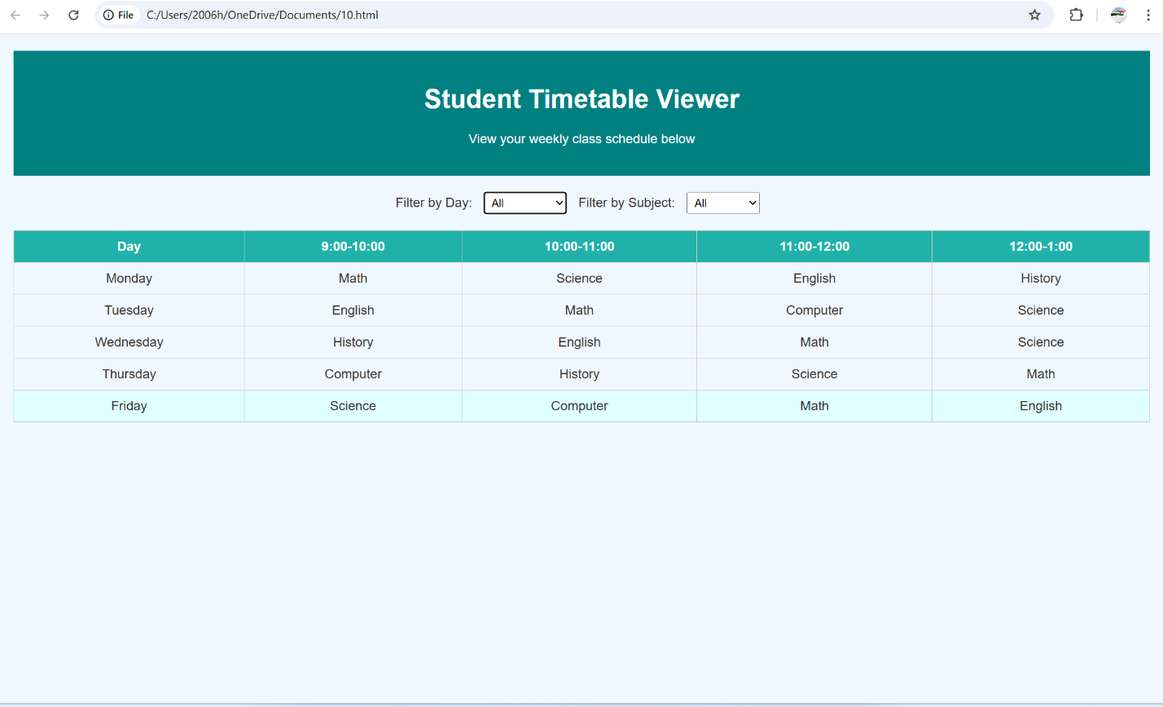

**🎓 Learning Outcomes**

By completing this project, students will:

* Understand how to create **HTML tables** to display structured data.
* Learn to style web elements using **CSS** including hover and responsive features.
* Use **JavaScript** to implement filtering logic based on user selection.
* Gain hands-on experience with **DOM manipulation** and **event handling**.
* Apply front-end web development skills to create a real-world educational tool.
* Improve UI/UX skills by creating a clean and navigable web interface.